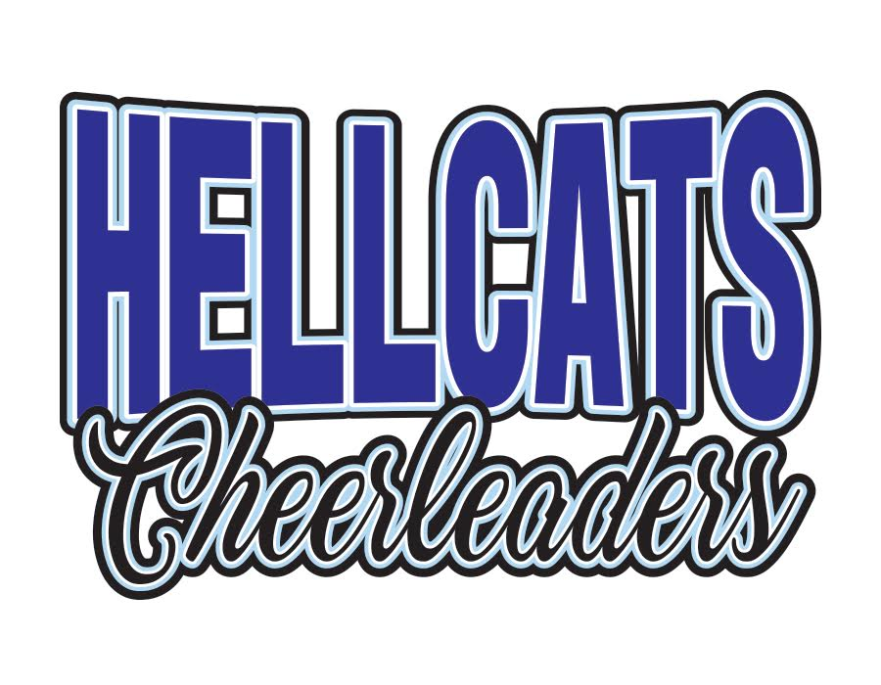

**JUNIOR COACHES APPLICATION PACK**

Thank you for your interest in joining the Hellcats Cheerleaders coaching team. Junior Coaches play a key role in the success of our teams, and this position provides you with the opportunity to share your cheerleading experiences and knowledge with others while giving you the chance to learn new skills as a mentor and instructor.

This pack contains some general information about what is involved and expected of our Junior Coaches.

**Requirements**

All Junior Coaches must:

* Be in at least Year 10 for the 2022/2023 season (beginning September 2022)
* Have had at least 2 years cheerleading experience with Hellcats
* Have a passion for cheerleading and a desire to instruct and mentor others
* Be in good academic standing and have a proven track record of good behavior, dedication, focus and determination in training
* Maintain a good attitude throughout the season including being a good example and role model to others

**Your Role**

If you are successful, you will be assigned to one of the Hellcats teams and given a Main Coach to assist. Your Main Coach will be an adult who has ultimate responsibility and will be your primary point of contact. The Main Coach will decide on the team’s goals for the season, what actions or duties will be expected of you, what part/parts (if any) you will be in charge of creating and any other responsibilities you may have. It will be down to you to ensure that you are supporting your Main Coach and helping the team to meet the goals set. You should use your initiative and get actively involved in training and build a rapport with your athletes. Your job is to assist the Main Coach and be as helpful as possible.

**Expectation of Commitment**

Applying for a Junior Coach position comes with the understanding that you are committing yourself and your personal time to volunteer as a member of the Hellcats coaching team. You will be expected to attend all training sessions for the team you are assigned to, unless otherwise approved by your Main Coach. You will also be expected to attend any other sessions or meetings that is required by the Head Coach. If you must miss a training session for any reason, you must inform your Main Coach in writing as early as possible and find cover for your shift. You will also be expected to attend a one-day BGU Junior Coaches training course (date TBC). We will also provide you with a copy of our in-house Junior Coaching progression workbook. This should be completed during your first season as a Junior Coach and the Head Coach may ask for you to turn in your workbook at multiple points during the season to keep an eye on your progress and understanding.

You also understand that you must lead by example, not only in the sessions you are coaching but also in the sessions you participate in as an athlete. Wherever possible, we intend to only have one junior coach per team so you should be aware that it is unlikely you will get to coach alongside your friends. If selected for our Junior Coaching program, we will have high expectations of you and will be eager to help you begin your coaching journey. Being a Junior Coach is a lot of fun, but it comes with a lot of responsibility. If successful, we expect you to acknowledge this and understand that being a junior coach is a privilege.

**WHAT HAPPENS NEXT?**

Please submit your application by 15th July 2022. If shortlisted, you will be invited to an interview and coaching trial with one of our teams. This will happen any time between July 18th and July 22nd.

If you have any questions, please do not hesitate to reach out to one of our coaches or email [laura@hellcatscheerleaders.co.uk](mailto:laura@hellcatscheerleaders.co.uk)

We can’t wait to read your application!



**APPLICATION FORM**

NAME:

AGE:

SCHOOL YEAR (SEPTEMBER 2022):

PHONE NUMBER:

EMERGENCY CONTACT NAME:

EMERGENCY CONTACT NUMBER:

PLEASE DETAIL YOUR CHEERLEADING EXPERIENCE:

WHY DO YOU WANT TO BE A JUNIOR COACH?

WHAT SKILLS CAN YOU BRING TO THE COACHING TEAM?

WHAT IS YOUR FAVOURITE THING ABOUT CHEER?

WHAT DO YOU THINK MAKES A GREAT COACH?

WHY DO YOU THINK **YOU** WILL BE A GOOD COACH?

DO YOU HAVE ANY PREVIOUS COACHING/TEACHING EXPERIENCE?

PLEASE LIST 3 STRENGTHS AND 3 AREAS FOR IMPROVEMENT (These don’t have to be cheer related!)